 |  |  | 

HOTEL HAND-OVER NOTES [PRINTSHOP]

Position
Ship
Date
Voyage Number
HON Latest Version | (please don't change)

Department Heads, Division Heads, and all Managers leaving the vessel or vacating the position for any reason must complete the Hand-Over report.
This report verifies that all aspects of the Hotel Department areas are reviewed with incoming staff to ensure the continuous and effective operation of the department/division. If there are topics that are not related or specific to your areas of operation, please mark them as N/A.
Two weeks prior to sign-off, prepare the handover document.
One week prior to sign-off - Review handover notes; Manager meets with Division Head.
Handover day - Outgoing Manager/Division Head/Hotel Director meets with Incoming Manager/Division Head/Hotel Director. Incoming/Outgoing Managers/Division Heads/Hotel Director agree amongst themselves. Agreement on acceptance of handover notes. Both Managers meet the Division Head.
One/two weeks into sailing – Review Success/Shortcomings of handover notes; the Manager meets with the Division Head.
Retention: All positions that fill out handover templates are required to save an electronic version on the ship’s server for 3 years, per the Company’s Legal Record Retention Policy. Reminder: Do not save any sensitive information (passwords, PIN numbers, etc.) on the electronic version of the hard copy of the handover document. Hard copies may be discarded at the end of the contract.

DISTRIBUTION

Position | Distribution
Division Heads* | HD
Manager | GSM | RM | BOM

*The Hotel Administrative Assistant may be required to file a copy of the Division Head’s hand-over notes on behalf of the Hotel Director as requested.
Three types of hand-over templates are provided for use:
Standard template used by Division Heads, Department Heads and Managers — flexi-scheduling template used by flexi-scheduling participants — position specific templates used by those positions that have additional topics to review specific to their areas and are not provided in the standard template.

Note: If there are any topics on the template not applicable to your specific area of the operation, “N/A” should be noted next to the topic.

SIGNING OFF  First Name and Last Name ___________________________________________  Signature _______________________________________ | SIGN ON  First Name and Last Name ___________________________________________  Signature ___________________________________________

TABLE OF CONTENTS

1. PASSWORDS & LOGIN INFO

ITEM | CREDENTIAL / COMMENT
PC / Laptop Login
Onboard Print (OBP)
Microsoft Outlook | (same as PC login)
Microsoft Teams | (same as PC login)
CrunchTime
MinIO
Lotus Notes
Administrator Machine Password
Other

2. EQUIPMENT & TOOLS

ITEM | CONDITION / NOTES
Laptop
Deck Phone
Deck Phone Charger
Keys (Print Lab / Storage Locker)
Toolbox
Vacuum
Webcam
Headphones
Weight Belt
iPad / Tablet

3. KEY DAY-TO-DAY CONTACTS

Role / Name | Deck Phone | Office # | Location / Deck
Cruise Director
Assistant Cruise Director
Business Operations Manager (BOM)
Hotel Director
Guest Services Manager (GSM)
F&B Manager
Marketing & Revenue Manager
Digital Manager
F&B Admin

4. OPERATIONAL NOTES
Key things the incoming specialist needs to know — pending items, contacts, quirks. Not procedures.

Pending Print Requests / Jobs

Upcoming Voyages — Files / Folders Prepared

Key Operational Notes (Compass, Insider, collaterals, etc.)

Next Order Due Date

Any Unusual Situations or Unfinished Tasks

5. MACHINE STATUS
MACHINE 1
Serial Number | Current Condition | Machine Model | Status
 | Good / Issues (see notes) |  | Operational / Down

Machine 1 — Recent Errors & Parts Replaced
Error codes encountered:
Troubleshooting performed:
Parts replaced (include date):
Pending parts / open issues:

Complete one block per machine. Include photos of drum, transfer belt, fusing unit, developing unit, feed rollers, ADU, and inside main unit.
Example photo (Developer Unit CYMK — Magnetic Roller Section):
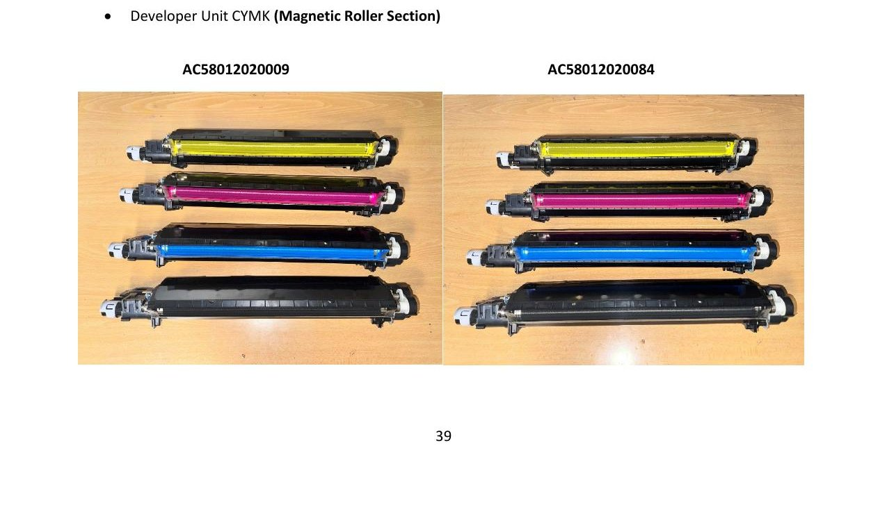
Label each photo with Machine Serial Number and Date

MACHINE 2
Serial Number | Current Condition | Machine Model | Status
 | Good / Issues (see notes) |  | Operational / Down

Machine 2 — Recent Errors & Parts Replaced
Error codes encountered:
Troubleshooting performed:
Parts replaced (include date):
Pending parts / open issues:

MACHINE 3
Serial Number | Current Condition | Machine Model | Status
 | Good / Issues (see notes) |  | Operational / Down

Machine 3 — Recent Errors & Parts Replaced
Error codes encountered:
Troubleshooting performed:
Parts replaced (include date):
Pending parts / open issues:

6. PARTS LIFE % VALUES

Items | Machine 1 | Machine 2 | Machine 3 | Machine 4
1st Transfer Roll Y
1st Transfer Roll M
1st Transfer Roll C
1st Transfer Roll K
2nd Transfer Roll Up
2nd Transfer Roll Lw
Transfer Belt
Transfer Belt Cl Unit
Fuser Belt Assy
Lower Fuser Roller
Developer Unit Y
Developer Unit M
Developer Unit C
Developer Unit B
Drum Unit Y
Drum Unit M
Drum Unit C
Drum Unit B
Charge Pole Y
Charge Pole M
Charge Pole C
Charge Pole B

SIGNING OFF  First Name and Last Name ___________________________________________  Signature _______________________________________ | SIGN ON  First Name and Last Name ___________________________________________  Signature ___________________________________________

7. CLICK COUNT ACCURACY
Formula: Previous Total Counter + Present CSV Counter = Present Total Counter. Discrepancies must be reported to shipsupport@dg3.com immediately.

KM Machine | Previous Total Counter (Last Month) | Present CSV Counter Report | Present Total Counter (from Machine) | Discrepancy
Printer 1 | Mono: Color: | Mono: Color: | Mono: Color:
Printer 2 | Mono: Color: | Mono: Color: | Mono: Color:
Printer 3 | Mono: Color: | Mono: Color: | Mono: Color:
Printer 4 | Mono: Color: | Mono: Color: | Mono: Color:

SIGNING OFF  First Name and Last Name ___________________________________________  Signature _______________________________________ | SIGN ON  First Name and Last Name ___________________________________________  Signature ___________________________________________

8. CURRENT INVENTORY
Attach complete printed inventory list signed by both outgoing and incoming. Send copy to Ray Guerra. Note any discrepancies below.

Part Number | Description | Par Level | Inventory | Machine Model

SIGNING OFF  First Name and Last Name ___________________________________________  Signature _______________________________________ | SIGN ON  First Name and Last Name ___________________________________________  Signature ___________________________________________

9. OPEN / INCOMING ORDERS

Order Date | Due Date | Voyage Number | Loading Delivery Date | # Items | Status

Next Order Due Date

Notes / Ordering Schedule

DG3 Diversified Global Group — Printshop Hand-Over Notes — Standard Form

