TRAINING GUIDE

CIMS Parts Request
How to submit parts, toner, technical parts or tools order through the CIMS ordering portal
Portal | order.cims.work
Who this is for | Any employee placing a part, toner, technical parts or tools order for a vessel
Estimated time | 5–10 minutes per order
Overview
This guide walks through every step of submitting a parts request in CIMS, from opening the portal to sending the final order. Follow the steps in order — each screen in CIMS depends on the choices made in the one before it.
Before you start, have this information ready:
- Your name
- The company and ship name for the order
- The machine serial number (for Production orders)
- Part numbers and quantities needed
- The port agent's name, phone number, address, and email

Step 1 Enter Your Name
Go to the CIMS ordering portal and enter your name to identify who is placing the order.
Portal address: order.cims.work
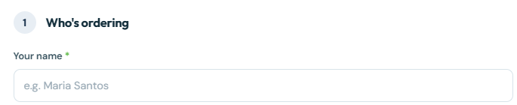

Step 2 Select the Company
Choose the company the order is being placed for.
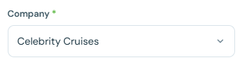

Step 3 Select the Ship Name
Choose the vessel that the order is for. This determines the delivery destination later in the process.
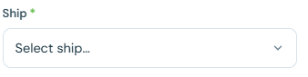

Step 4 Choose What You're Ordering
Select the order type from the dropdown:
- Production — for toners, parts, and technical parts
- Tools — for tool orders
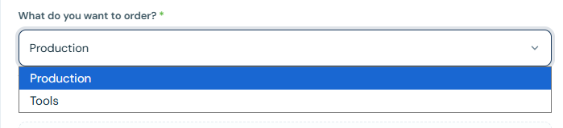
TIP: Choosing the wrong type here will show the wrong item catalog on the next screen.

Step 5 Select the Machine Serial Number
Choose the correct machine serial number the parts are needed for.
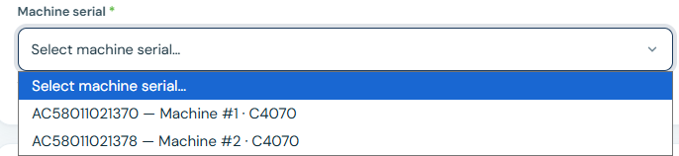

Step 6 Find and Add Your Parts
Select “All Production” and search for each item by part number.
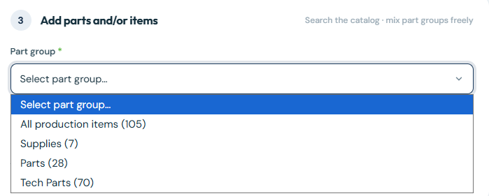
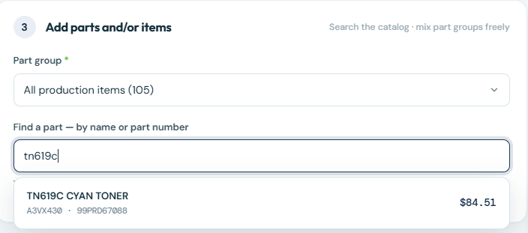
IMPORTANT: If a part number isn't available in the catalog, email Ray to have it added.

Step 7 Enter Quantities
Enter the correct quantity needed for each part added to the order.
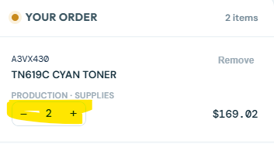

Step 8 Select Delivery Dates
Choose the next available port dates for delivery. You must select at least 3 dates — CIMS ships to the earliest date and keeps the rest as backups and reminders for the vessel to check with the port agent.
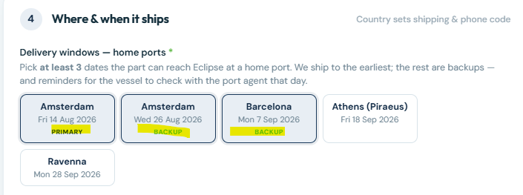

Step 9 Enter the Port Agent's Information
Fill in the port agent's full contact details:
- Name
- Phone number
- Address
- Email address
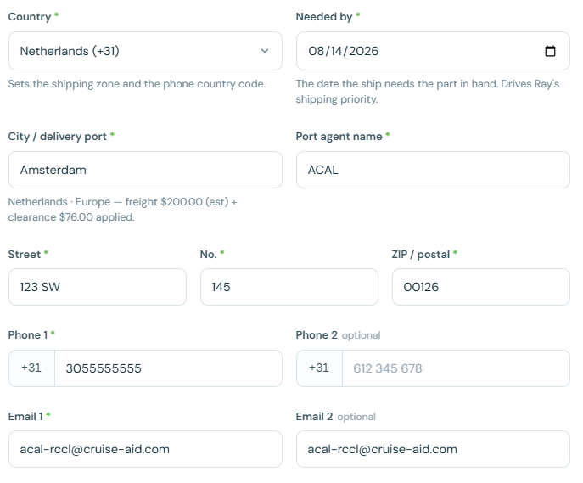

Step 10 Add Notes
Enter clear, valid notes describing the situation for this order.
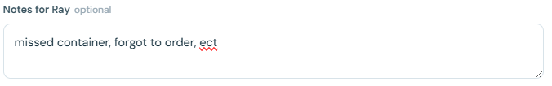

Step 11 Choose the Order Type
Select the order category that matches the reason for this request:
- Regular order — for technical parts requests that are not toner or part-par-level related
- Missed order — for any order that resulted from a problem, such as something that should have already been ordered
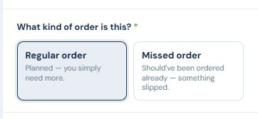
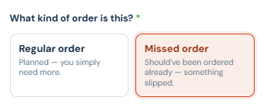

Step 12 Describe What Happened
If you selected Missed Order, choose the description that best matches the situation:
- Shore planning miss — rationed, under-forecast, or not reordered in time
- Vessel-side miss — the need wasn't flagged from the ship in time
- Equipment / unexpected — failure or abnormal use, no one's fault
- Other — add a note explaining the situation
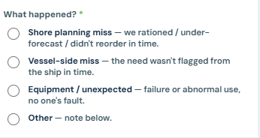
Step 13 Review and Submit
Before sending, verify that everything has been added to the order correctly. Confirm the request is accurate, then send it.
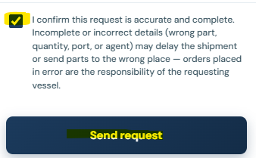
IMPORTANT: Double-check part numbers, quantities, and delivery dates before submitting — orders cannot be edited once sent.

Quick Reference Checklist
- Name entered
- Company and ship selected
- Correct order type (Production or Tools) chosen
- Machine serial number selected
- All needed parts added with correct quantities
- At least 3 delivery dates selected
- Port agent's full contact information entered
- Notes added describing the situation
- Regular order or Missed order correctly selected
- Order reviewed and confirmed accurately before sending

